Module 1 Challenge

* Given the provided data, what are three conclusions that we can draw about crowdfunding campaigns?

Conclusion 1:

People tended to participate in film & Videos, music, and theater (total: 697) rather than other categories event such as technology, games, photography (total:186). This should be the focused area to initiate future campaigns.

Conclusion 2:

June and July tend to generate more successful compaigns compared with the rest of the months.

Conclusion 3:

Theater has the most participates and more than 50% success rate.

* What are some limitations of this dataset?

Currency is not standardized so it is difficult to access based on average donations.

* What are some other possible tables and/or graphs that we could create, and what additional value would they provide?

I would provide a new formula to standardize the average donation based on currency conversions internationally. Then I will look at how the donation distributions across the world.

Bonus

The median better represented the data because large variation and the existence of outliers.

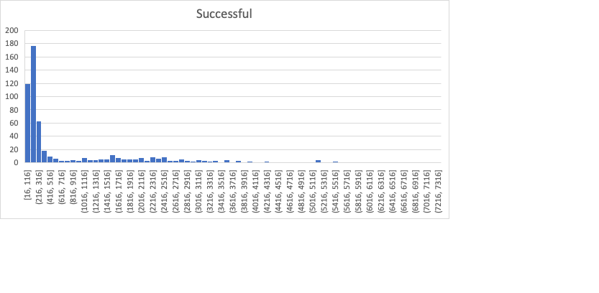

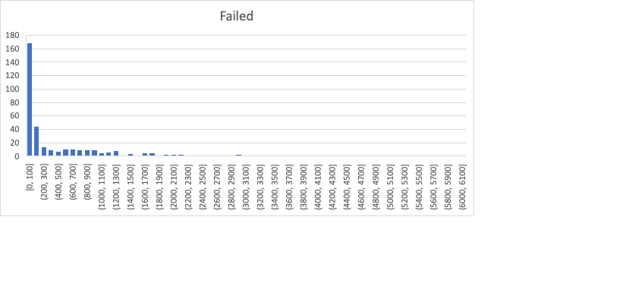

There is more variation among failed campaigned due to large standard deviation and the distribution does not appear to be close to gaussian but rather skewed. This makes sense from above histogram to look at the distribution.